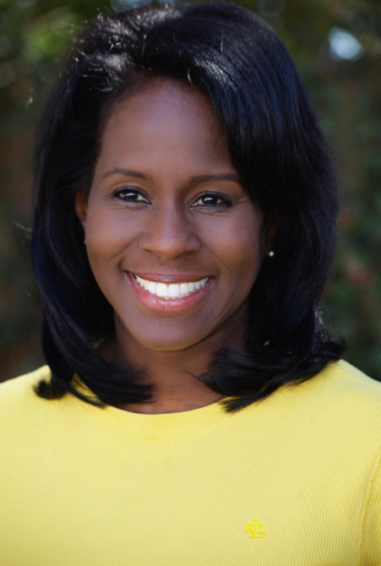
SB Media Press Release:
May 25, 2015
LaRita Shelby's "Dictation" to be produced by the Caribbean Community Theatre in St. Croix, U. S. Virgin Islands

Caribbean Community Theatre (CCT) on St. Croix in the U.S. Virgin Islands has announced plans to produce selections from Dictation: Plays, Poems & Monologues by Los Angeles based actress, entertainer & media professional LaRita Shelby. Seven performances will be held over three weekends at CCT: June 5 – 20, 2015.

The St. Croix production of Dictation makes for the Caribbean Community Theatre's second adaptation of this work. The first was in 2003 under the direction of Marsha Munchez. The 2015 production is directed by Eileen Bishop Des Jardins and Xiomara Sanchez. Miss Shelby's humorous and dramatic spin on love, life and relationships evolve in dramatic skits and humorous monologues such as My Thigh Moved, Identity, I Left Generations Sitting on the Stoop, Butterflies & Trees, No Apologies and She Wanted Me to Miss the Game! Certain poems and monologues from the CCCT's presentation have been translated into the local Crucian dialect.
Selections from Dictation have been performed by the Los Angeles cast of Feelings; The Mattie Theater Company and Made Line Productions in New York, and the "Yo' Memphis" Performing Arts Troupe. The short play Espresso Cafe' was selected by the NAACP Beverly Hills/Hollywood Theatre Festival in 2014 and in the same year Miss Shelby was the Honorary Chairperson of the Women's Theatre Festival of Memphis. LaRita was inspired to write by her late aunt Mary (a gospel playwright) and LaRita's fifth grade teacher from Clark Elementary in Washington, D. C.
LaRita holds a B.A. in Theatre Arts from Loyola Marymount University, and a Masters in Media & Communication Psychology from Touro University Worldwide. Currently LaRita teaches drama at a mental health facility for teens, she's the Director of Digital Strategy at EURweb.com and she's celebrating her son's high school graduation. LaRita has released one album titled A Date with a Song with collaborator Willie Daniels, and a single in tribute to First Lady Michelle Obama called Mr. President's Girl (avail online by Rita Shelby).
To order a copy of the book Dictation: Plays, Poems & Monologues go to LaRitaShelby.com. For tickets and information for the Caribbean Community Theatre go to www.cct.vi.
Photo credit: BK Thomas Hair & Make up: Sir Tony

